Release Assembly - TC Cockpit All Projects Management Page Update Deployment Guide

Revision History
Author | Revision Number | Date
TCSASSEMBER | 1.0 | 03/22/2011

Deployment Instructions 3
1. Organization of Submission 3
2. Application Setup 3
2.1 Ant .Properties File 3
2.2 Build Scripts Setup 3
3. Database Setup 4
4. Deployment Instructions 4
5. Starting 4
6. Verification 4
7. Resource Contact List 5

Deployment Instructions

Organization of Submission

The submission follows directory structure provided below:

doc
Contains the Deployment Guide Document of this assembly.

direct
Contains sources and static files for Direct web application. This directory replicates the application development distribution structure and includes only updated and new files.
Scripts
Contains all the updated queries for updating database script trunk

test_files
Contains the SQL files to insert the test data

Application Setup

The application is expected to be deployed to the following environment:

JRE 1.5
JBoss 4.2.3.GA
Informix DS 11.5

Ant .Properties File

No .properties files are modified.

Build Scripts Setup
The ANT build script for Direct application (build.xml) provides the following targets which are to be used:

- switch-and-checkout – checkout or switch to the defined source code branches for all components defined in subprojects.xml
- dist-backend – rebuilt all the components from the source code.
- first_deploy – must be the first task to execute from command line. It will copy all dependencies to your local JBoss folder.
- deploy – should be the main task to execute from command line. It will build and deploy WAR file.
- deploy-static-files – deploys the static files to JBOSS.
- deploy-apache-static – deploys the static files to apache server on VM.

Please refer here for more information:
http://www.topcoder.com/wiki/display/docs/TC+Direct+Setup+Guide

Database Setup

Add new metadata keys for project ratings
- Run test_files\insert_rating_metadata_keys.sql on database

Update and add queries via Query Tool

Log into the TC Query Tool to add the new query (on VM use http://tc.cloud.topcoder.com/query/query)

Update the query direct_my_projects_contests
- Choose the database TCS_CATALOG
- Click Query List and choose the query direct_my_projects_contests
- Paste the updated contents in scripts\tcs_catalog\query_tool\ query_direct_my_projects_contests.txt and Save

Deployment Instructions

This section provides the instructions in Production environment.

- Merge the code from submission into SVN for Direct application
- Go to directory contest_service_facade, run ‘ant dist_tcs’
- Go to directory topcoder_cockpit_project_metadata_entities, run ‘ant dist_tcs’
- Go to directory topcoder_cockpit_project_metadata_services, run ‘ant dist_tcs’
- Build and deploy Direct application using ant deploy (or ant first_deploy ) command.
- Copy static files using ant deploy-static-files command or ant deploy-apache-static if use apache as static file server.

Starting

- Build and deploy the Direct application
- Start JBoss server instance hosting Direct application

Verification

Set up test data first, run the following SQL scripts in order against the test server database:
- test_files/ 1) test_data.sql
- test_files/ 2) insert_group_keys_and_values.sql
- test_files/ 3) insert_empty_project_and_forums.sql

Run the tcs_dw load scripts to load the contest, direct projects, billing accounts and client data into tcs_dw
- If you test on VM, you can login as account tc, and go to /home/tc/web/scripts/dwload
- Run “./loadtcsscript.sh” to load data

Use various browsers to open the link http://localhost:8180/direct or https://[vm_ip]/direct , login as heffan / password.

After login, click the “Projects” 

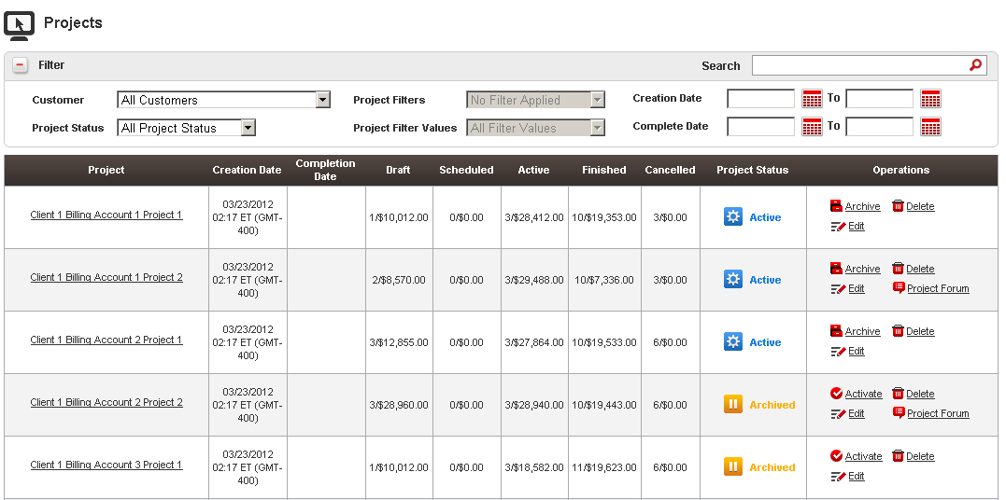

Check Status Change feature, click the ‘Archive’ button of first row

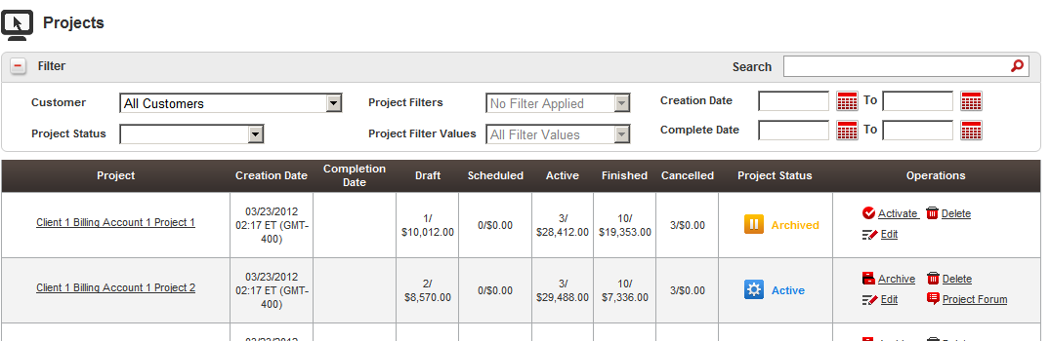

It turns to “Archived’, click the ‘Activate’ again will activate it

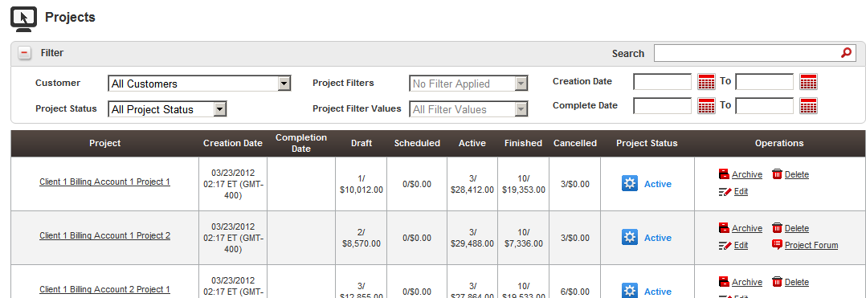

Click edit will open edit project in new window

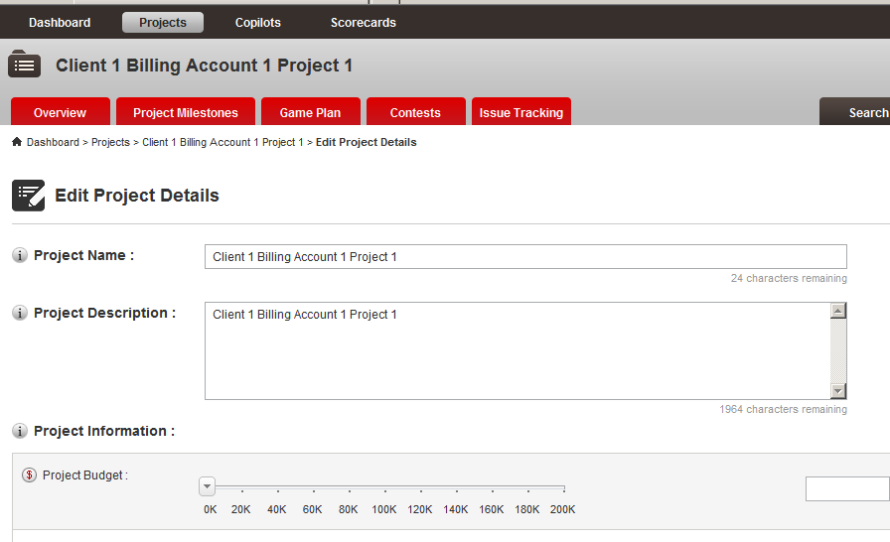

Click forum will open forum in new window

If project does not have forum, forum icon is not displayed

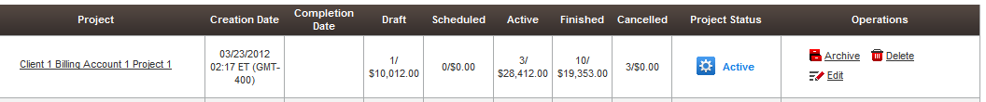

Choose a customer in filter panel

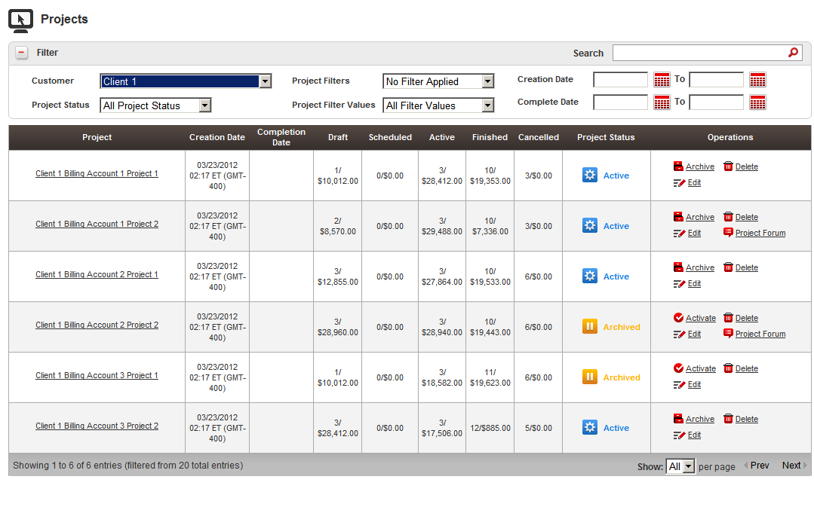

Check Project Filters

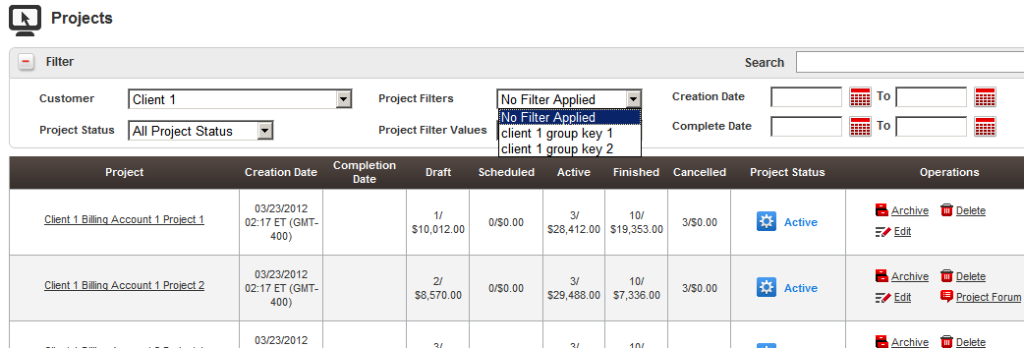

Choose the client 1 group key 1, check Project Filter Values

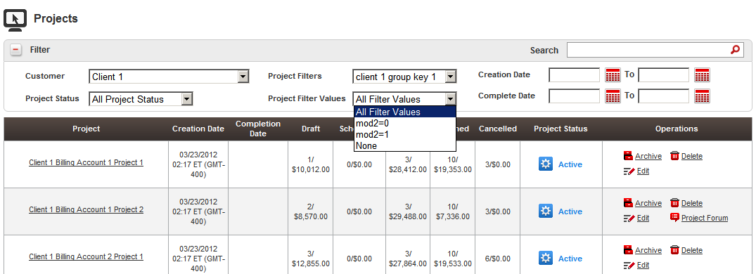

Choose mod2=0, the project is filtered

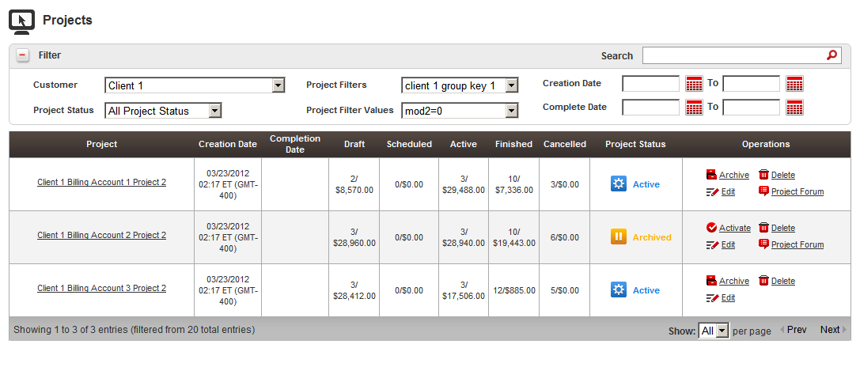

Choose key 2 and test none

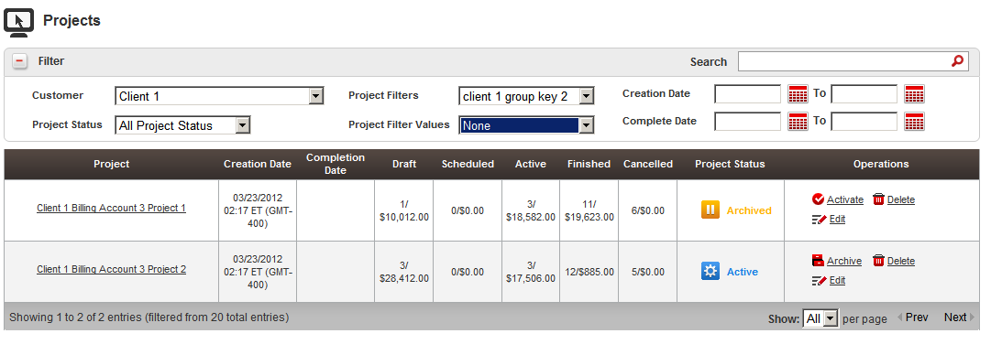

Choose another customer and test other project filters

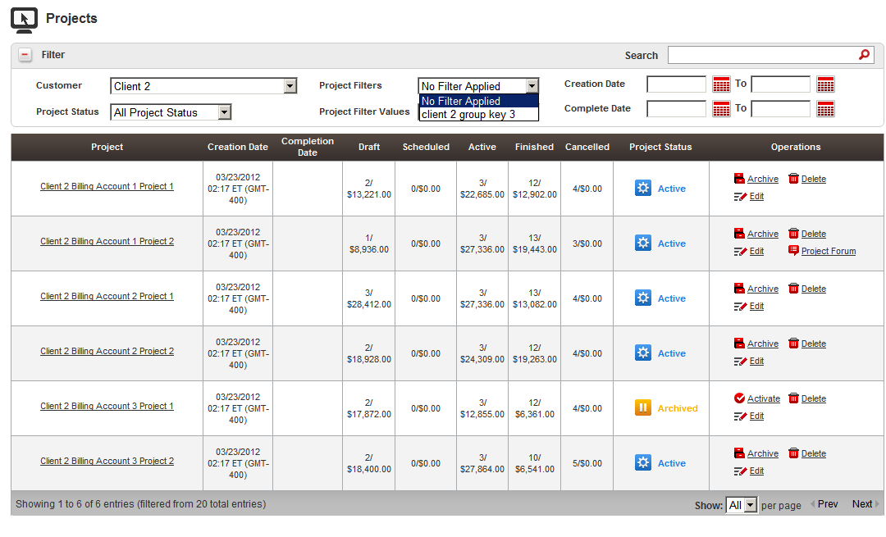

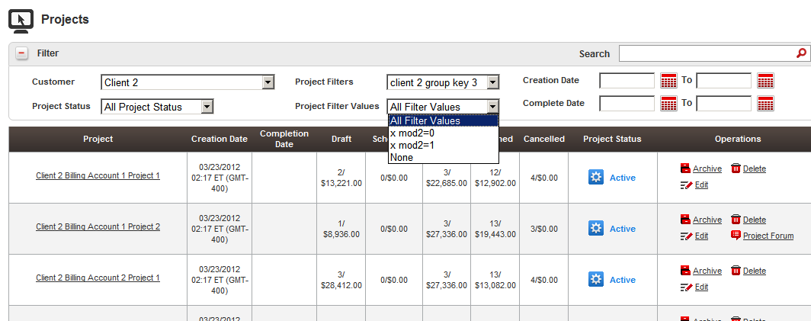

Go to edit project, you can mark project as deleted or completed

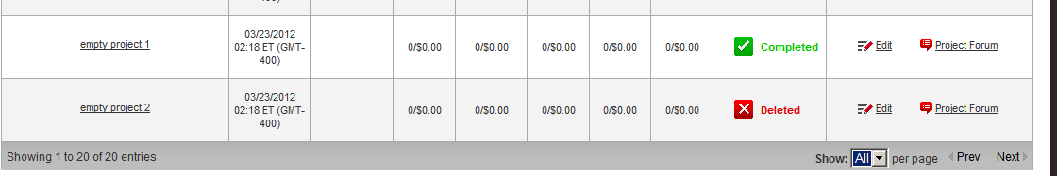

Test the search projects

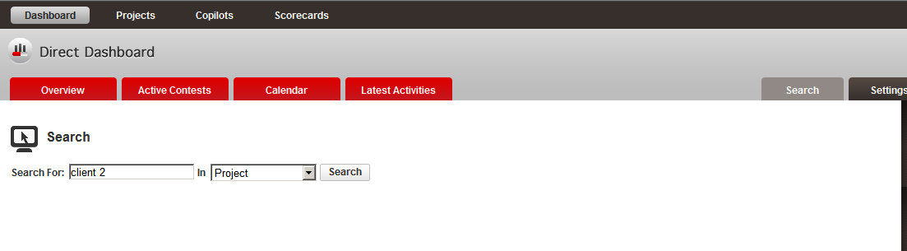

Click Search button

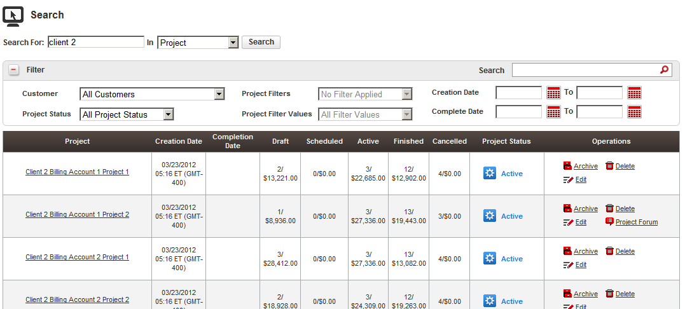

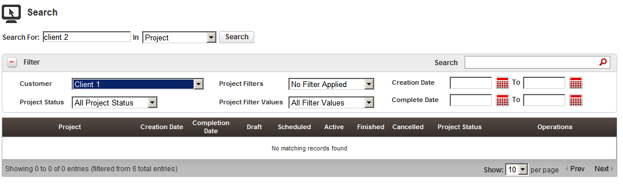

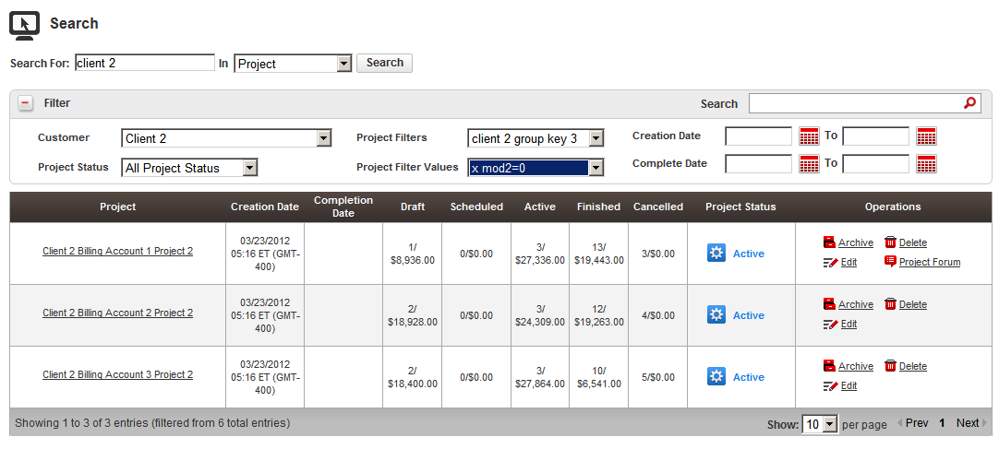

Resource Contact List

Name | Resource Email
TCSASSEMBER

